**Task 4: Setup and Use a Firewall on Windows**

**🛠 Tools Used**

* **Operating System**: Windows 10/11
* **Firewall**: Windows Defender Firewall (Advanced Security)
* **Command Prompt** for testing connections
* **Telnet Client** (Optional Feature)

**📋 Steps Performed**

**1. Opened Firewall Configuration Tool**

* Opened the Run dialog (Win + R) → Entered wf.msc to launch **Windows Defender Firewall with Advanced Security**.

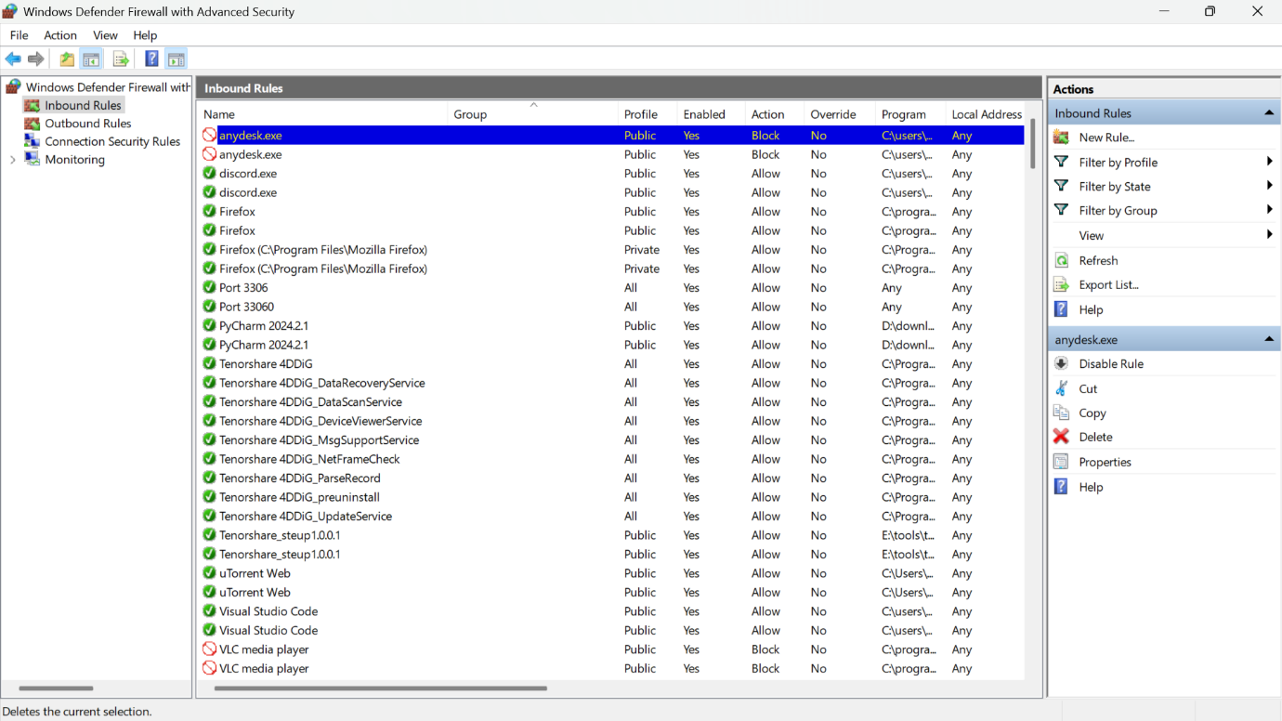

**2. Blocked Inbound Traffic on Port 23 (Telnet)**

* Created a **New Rule**:
  + Rule Type: **Port**
  + Protocol: **TCP**
  + Port: **23**
  + Action: **Block the connection**
  + Applied to: Domain, Private, Public
  + Name: **Block Telnet Port 23**

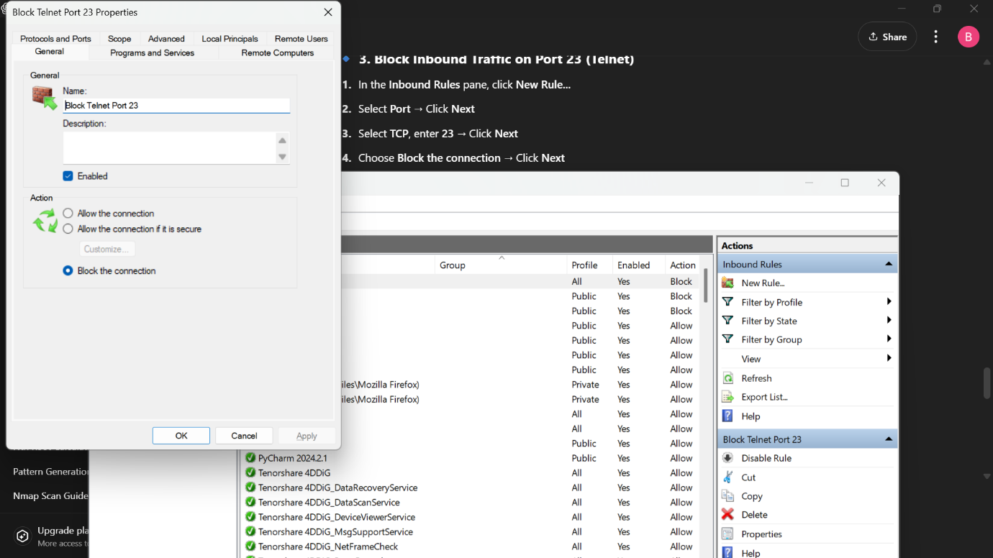

**4. Tested the Rule**

* Used Telnet in CMD to test the blocked port:

telnet localhost 23

* Result: Connection refused or failed, indicating the rule was effective.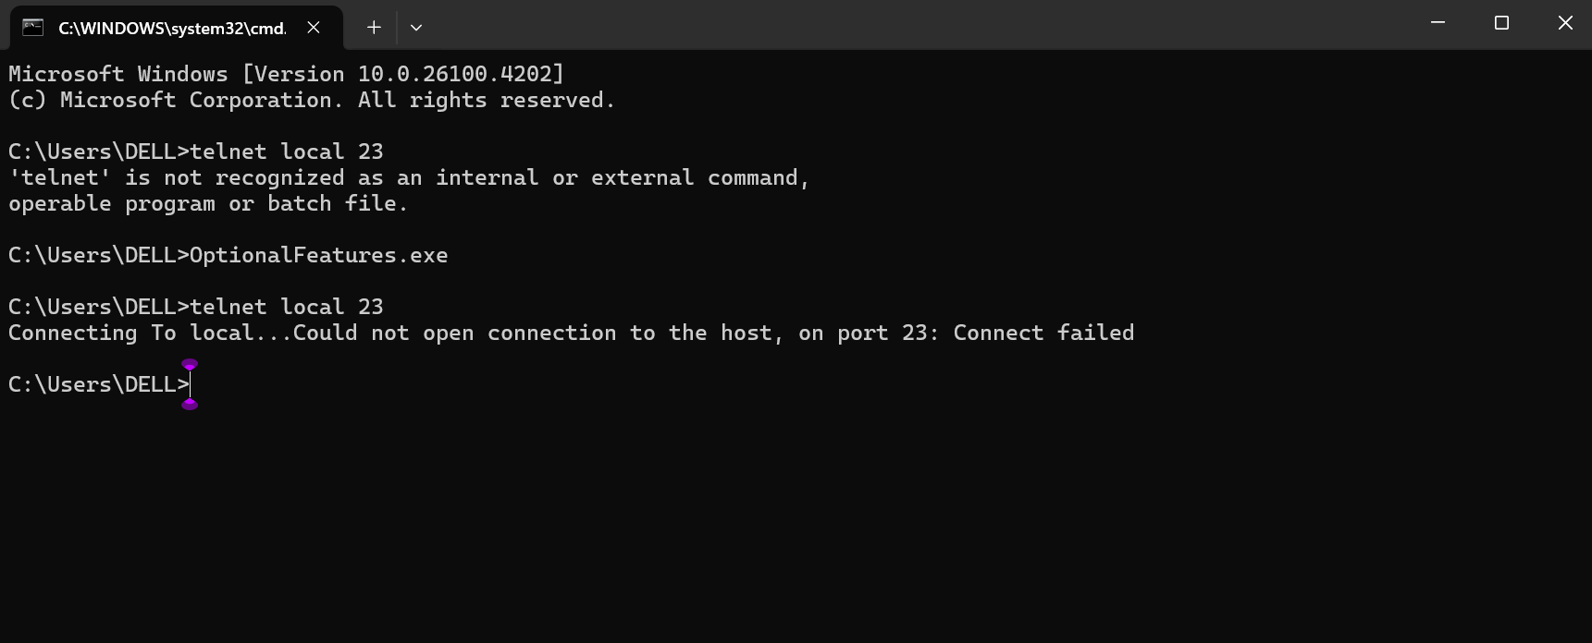

**5. Allowed Inbound Traffic on Port 22 (SSH)**

* Created a **New Rule**:
  + Rule Type: **Port**
  + Protocol: **TCP**
  + Port: **22**
  + Action: **Allow the connection**
  + Name: **Allow SSH Port 22**

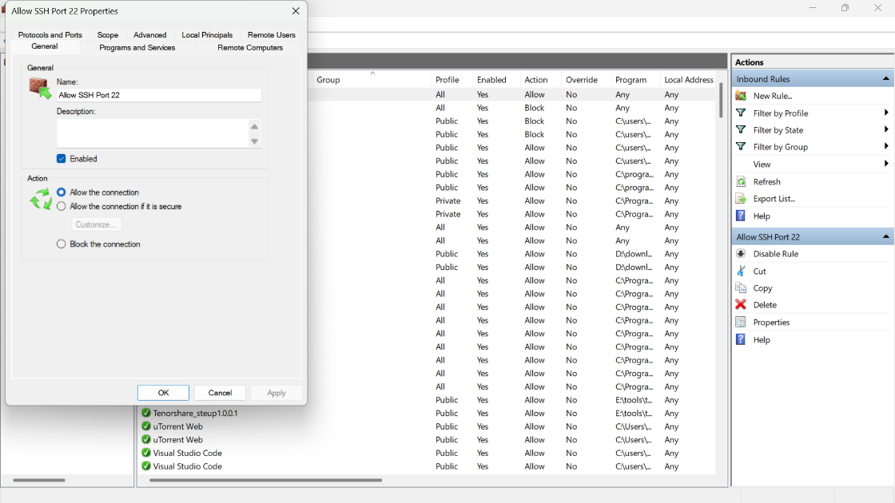**6. Restored Original State**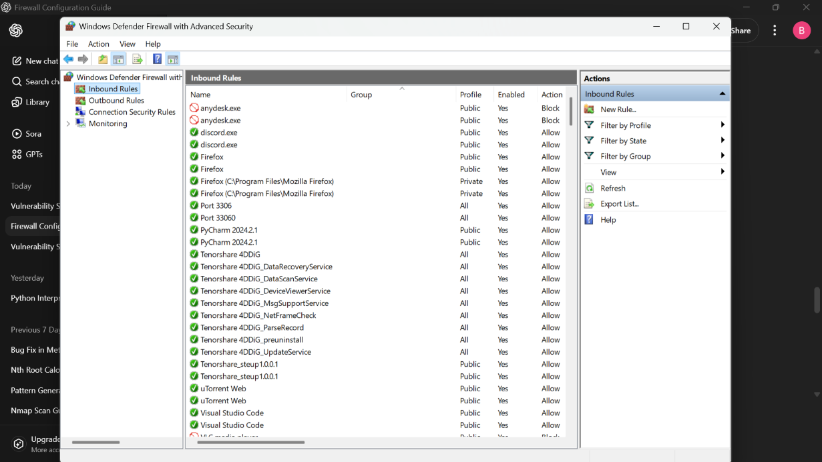

* Deleted the test rule (**Block Telnet Port 23**) from Inbound Rules.

**📌 Commands Used (For Testing)**

telnet localhost 23

**📖 Summary: How Firewalls Filter Traffic**

Firewalls act as gatekeepers that monitor and control incoming and outgoing network traffic based on pre-defined security rules.

* **Inbound rules** filter data trying to enter the system.
* **Outbound rules** control data leaving the system.
* **Blocking Telnet (port 23)** helps prevent unauthorized and insecure remote access.
* **Allowing SSH (port 22)** supports secure communication when needed.
* Firewalls help reduce attack surfaces and protect sensitive systems by minimizing unnecessary network exposure.

**Conclusion**

Successfully configured, tested, and reverted firewall rules on Windows. This task demonstrated hands-on understanding of network traffic control using built-in security tools.

Let me know if you’d like this exported as a **.docx** or **PDF file** with placeholders and formatting.